Required Capstone Checkpoint 2.1: Retrieval Strategy Design and Baseline Implementation

Directions

You will continue working with the same dataset and scenario you selected for your capstone checkpoint in Module 1. In this activity, you will design and implement a baseline retrieval system that supports the types of queries required for your scenario.

Download this worksheet and save a copy to your device before you begin working. Type your responses directly into the document, save your completed work, and upload the finished file when you are ready to submit.

Use this worksheet to:
- Document your retrieval approach
- Capture representative retrieval queries and results
- Provide evidence that your retrieval system is functioning
- Observe how retrieval performance changes across different query types
- Reflect on where the retrieval approach performs well and where it struggles

1. Selected Scenario and Retrieval Approach
- Identify your chosen capstone scenario.
- Describe the retrieval approach you implemented (keyword-based, semantic, or hybrid).
- Briefly explain why this retrieval approach is appropriate for your dataset and query types.
- Describe any trade-offs you considered when selecting this approach
Scenario
☐ Research Paper Navigator
☒Wikipedia Retrieval Engine
Retrieval approach used, brief explanation, and description of trade-offs considered
I used Hybrid Retrieval which includes Vector search and lexical search i.e. bm25, combined together and rank fusion to get best match top results.
BM25 Lexical Search finds match based on exact keyword. It is good to use for matching specific text, date, term, etc. It fails if the exact terminology is missing.

Vector Search encodes queries and Wikipedia text chunks into vector embeddings using 'embedding-3-small' embedding model. It computes cosine similarity to retrieve based on semantic meaning, context, synonyms even when exact keywords do not match. It can miss exact dates, words used in search. It needs high storage and computing.

Hybrid Fusion combines both Vector and BM25 using RRF using top K to produce a balanced list of docs before passing them to LLM to generate the response

2. Baseline Retrieval System Evidence
- Provide evidence that your retrieval system was implemented and tested.
- Evidence may include screenshots, logs, outputs, notebook examples, code snippets, or brief descriptions showing that retrieval queries were executed successfully.
Evidence of retrieval system implementation and testing
Downloaded a couple of Wikipedia pages related with USA elections from 2020 to 2024 and stored those into a directory 'WikiFiles'. Used that folder to create the vector embeddings and for Hybrid Retrieval as highlighted in screenshot here

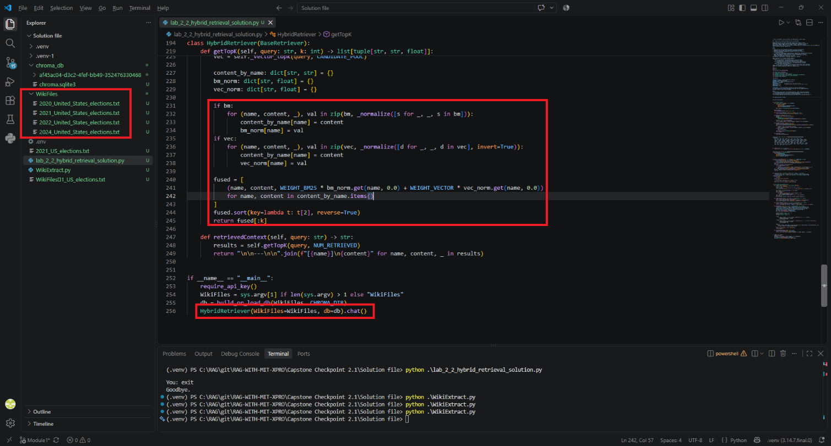

3. Representative Queries and Retrieved Results
- Provide three to five representative queries relevant to your scenario.
- Include the retrieved results for each query.
- Focus on showing how the retrieval system behaves across different types of information needs. Where possible, include a mix of precise, conceptual, or broader exploratory queries.
Query 1
Query: who was the head of the state when men landed on moon?

Retrieved results: The head of state at the time the Apollo 11 crew landed on the Moon (20 July 1969) was **President Richard Nixon** of the United States. The mission record notes that, after “Tranquility Base” had been declared, “President Richard Nixon … spoke to them … ‘Hello, Neil and Buzz…’”【Apollo 11.txt†L1730-L1744】.

Observations:
In the text file that I used as Wikipedia source file, does not contain phrase 'Head of the State' rather it says President Richard Nixon…
Since I am using Hybrid of Lexical and Vector embedding. It could find the meaning of 'Head of the State' is President and provided the correct answer.

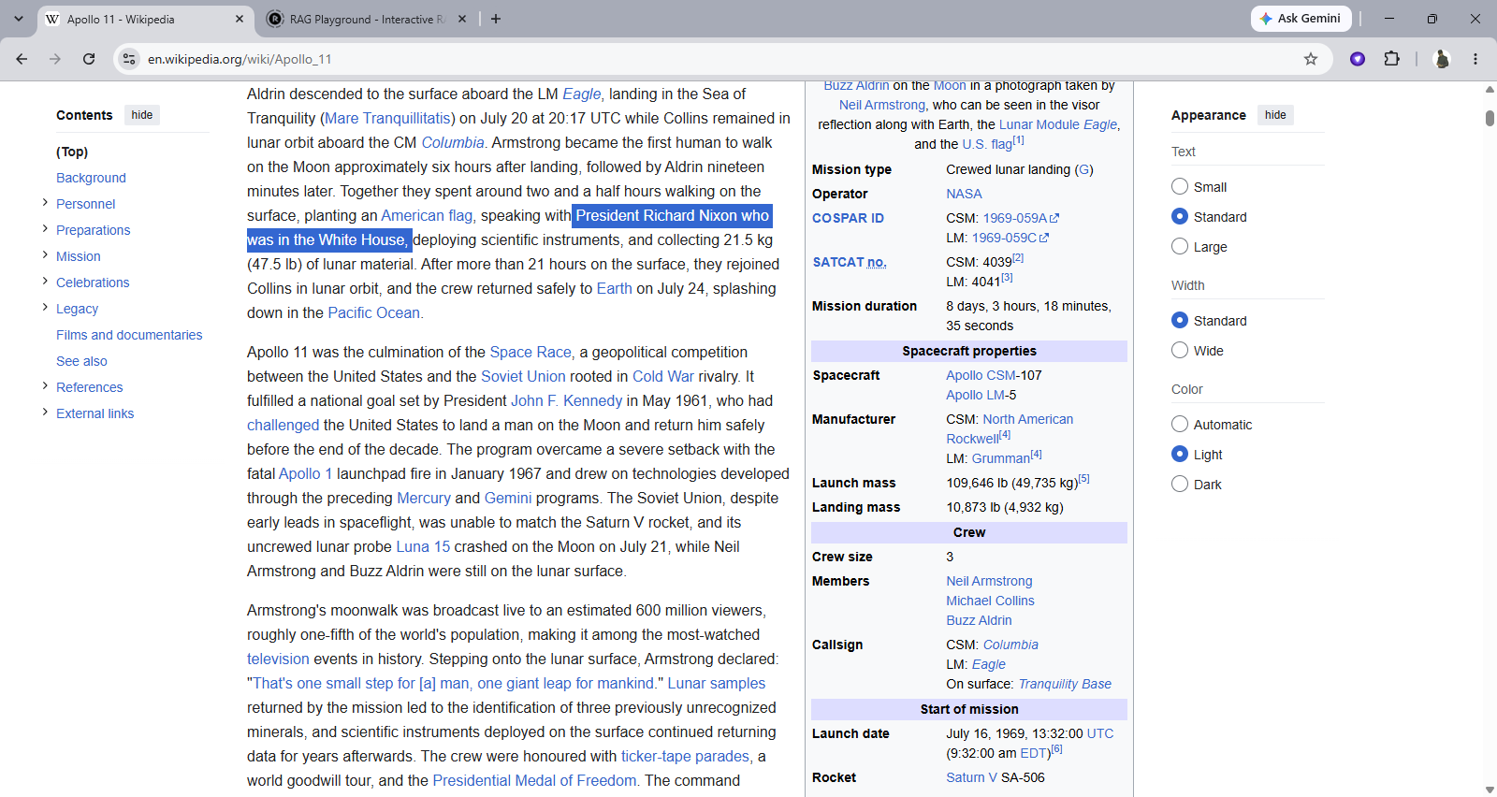

Query 2
Query:
When did Apollo One failed?
Retrieved results: Apollo 1 was lost in a launch-pad fire on **January 27 1967**【Apollo 11.txt†L613-L617】.

Follow up Query: what was the reason for fail?
Retrieved results:
The Apollo 1 tragedy was a launch-pad fire that killed the crew (Gus Grissom, Ed White and Roger B. Chaffee) on **January 27 1967**【Apollo 11.txt†L613-L617】.

The Apollo 11 article notes that the fire “abruptly halted” the program and mentions “the subsequent investigation,” but it does **not** provide details on the underlying cause of the fire. Therefore, based on the supplied WikiFiles, the specific reason for the failure – the technical or procedural factors that led to the fire – is not described.

Observations:
It worked well as reason for failure (fire) is mentioned in the Wikifile provided, the Model has not provided that information and mentioned as expected that this information is not available.

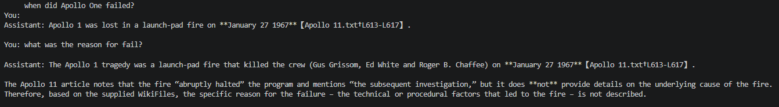

Query 3
Query: How many days passed between the selection of lunar orbit rendezvous as the Apollo mission mode and the fatal fire during the launchpad test?

Retrieved results:
The Apollo program officially adopted **lunar-orbit rendezvous (LOR)** as its mission mode in **July 1962** when NASA’s James Webb announced that the new approach would be used【Apollo 11.txt†L384-L389】.
A little more than four and a half years later the program was halted by the **Apollo 1 launch-pad fire on 27 January 1967**, which killed the crew of Grissom, White and Chaffee【Apollo 11.txt†L436-L442】.

Counting the days from 1 July 1962 (the first day of the month in which LOR was announced) to 27 January 1967 gives:

* 1 Jul 1962 → 1 Jul 1963 = 365 days
* 1 Jul 1963 → 1 Jul 1964 = 366 days (leap year)
* 1 Jul 1964 → 1 Jul 1965 = 365 days
* 1 Jul 1965 → 1 Jul 1966 = 365 days
* 1 Jul 1966 → 27 Jan 1967 = 210 days

**Total = 365 + 366 + 365 + 365 + 210 = 1,671 days**

So **1,671 days** elapsed between the selection of LOR as the Apollo mission mode and the fatal Apollo 1 fire.
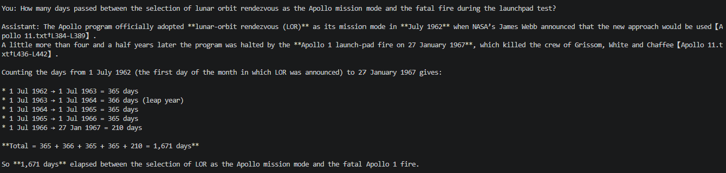
Observations:
There is reference of multiple docs. The information is not available directly. The Model has calculated the days starting from 1Jul 1962 while it should have used the James Webb's announcement date of July 11, 1962

Optional Additional Queries
Query: what was the height of Saturn V rocket?
Retrieved results: The provided WikiFiles do not contain any information about the height of the Saturn V rocket, so I’m unable to answer that question from the given source.

Observations: The information is present on the page but still Hybrid approach is failing to get the answer. It means that neither BM25 nor did the Vector could short that chunk in Top K. BM25 failed because the word 'Height' is not referenced in source document and Vector might have failed because it was pushed too low. Let me try changing Top K…
I tried changing the Weightage of BM25 to 0.1 and Weightage of Vector to 0.9 and TopK to 400 from 4. but still no luck.

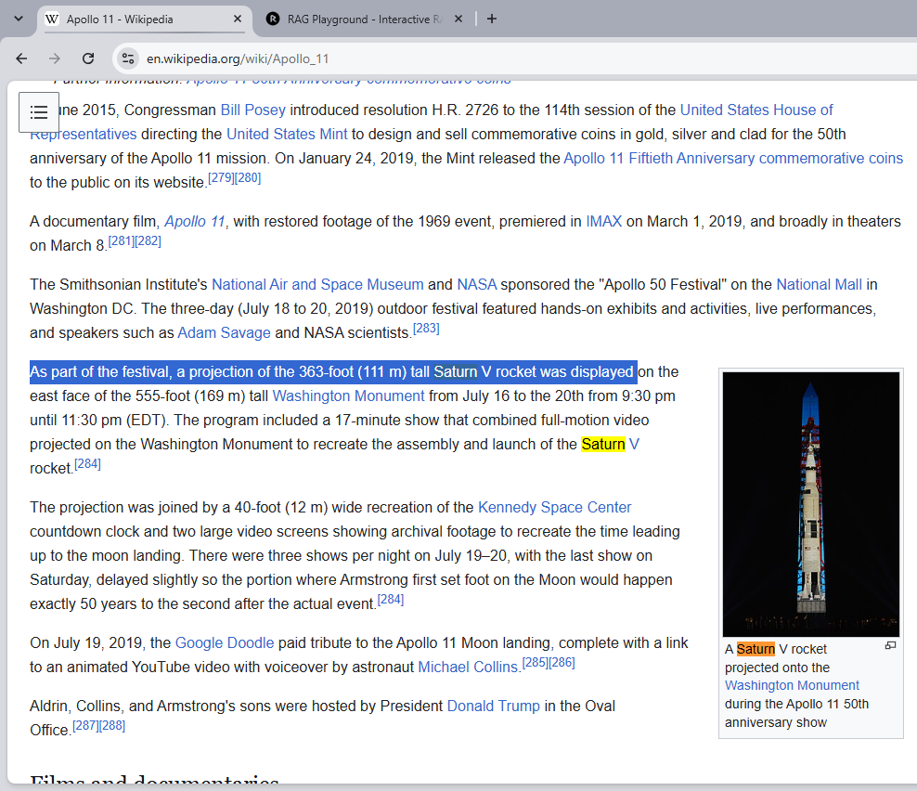

4. Retrieval Performance Reflection
- Reflect on where your retrieval approach performs well and where it struggles.
- Consider how different query types affect retrieval quality, relevance, flexibility, or precision.
Retrieval strengths
The strength of Hybrid Retrieval lies in its ability to combine the two search techniques 1) Lexical Search (BM25) and Vector Search. By leveraging both techniques through a fusion logic, hybrid retrieval overcomes the individual limitations of each approach

Retrieval limitations or challenges
As shown in example able the days calculation logic; query requiring cross-section context gathering and chronological math (Query3: calculating the exact days between the lunar-orbit rendezvous decision in 1962 and the Apollo 1 fire in 1967).

The limitation is the retrieval works and returns the chunks containing the relevant timestamps, but it could not figure out the day of the month in a multi-step dependencies across document sections.

Patterns observed across different query types
Strength: Queries containing specific dates, mission identifiers ("Saturn V," "January 27, 1967") yielded the highest precision. lexical search (BM25) answered these queries, preventing embeddings from diluting low-frequency exact
Limitation: Queries requiring cross-chunk comparisons or date calculations (computing the days between the LOR decision and the Apollo 1 fire) consistently exposed a pattern where retrieval succeeded in isolation but failed in integration.

5. Retrieval Strategy Reflection
If you were continuing to improve this system, would you keep the same retrieval approach or make changes? Explain your reasoning.
Reflection
- Hybrid approach worked well until I found an issue with one of the questions. The answer of the question is present in the Wikifiles but Model is unable to find it. The details are given above under "Optional Additional Queries". Need to discuss the reason behind this failure, find the root cause and fix in next version
- I faced program crash a few times when continuing with the follow up questions with multiple files loaded in chroma_db. It gave me error on size limitations. Seems like, the current implementation is not able to handle the large embeddings; Need to work to fix it.

Supporting Materials
Additional Evidence (Optional):
Git- https://github.com/merasupermarket/RAG-WITH-MIT-XPRO
Wikipedia- https://en.wikipedia.org/wiki/Apollo_11

End of Required Capstone Checkpoint 2.1
Return to the assignment page in the learning platform to upload and submit your completed capstone checkpoint and complete any remaining items in this module.

